**Exercise 1: Control Structures**

**Scenario 1:** The bank wants to apply a discount to loan interest rates for customers above 60 years old.

* + **Question:** Write a PL/SQL block that loops through all customers, checks their age, and if they are above 60, apply a 1% discount to their current loan interest rates.

DECLARE

CURSOR senior_customers IS

SELECT c.CustomerID

FROM Customers c

WHERE TRUNC(MONTHS_BETWEEN(SYSDATE, c.DOB) / 12) > 60;

BEGIN

FOR cust_rec IN senior_customers LOOP

UPDATE Loans

SET InterestRate = InterestRate * 0.99

WHERE CustomerID = cust_rec.CustomerID;

END LOOP;

COMMIT;

DBMS_OUTPUT.PUT_LINE('Data after 1% discount:');

END;

/

SELECT * FROM Loans;

**OUTPUT :**

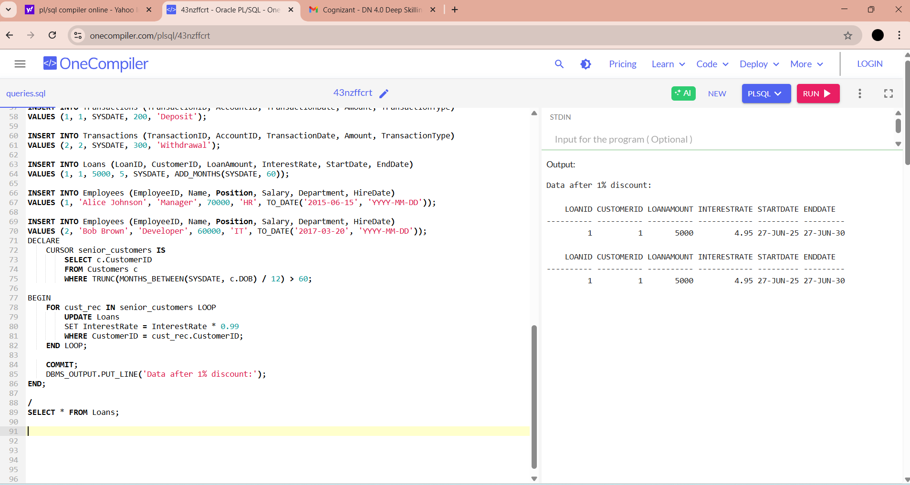

**Scenario 2: A customer can be promoted to VIP status based on their balance.**

* + **Question**: Write a PL/SQL block that iterates through all customers and sets a flag Is VIP to TRUE for those with a balance over $10,000.

ALTER TABLE Customers ADD IsVIP VARCHAR2(5);

DECLARE

CURSOR senior_customers IS

SELECT c.CustomerID,c.Balance

FROM Customers c;

BEGIN

FOR cust_rec IN senior_customers LOOP

IF cust_rec.Balance>10000 then

UPDATE Customers

SET IsVIP = 'TRUE'

WHERE CustomerID = cust_rec.CustomerID;

else

UPDATE Customers

SET IsVIP='FALSE'

WHERE CustomerID=cust_rec.CustomerID;

END IF;

END LOOP;

COMMIT;

DBMS_OUTPUT.PUT_LINE('VIP status updated based on balance.');

END;

/

SELECT * FROM Customers;

**OUTPUT:**

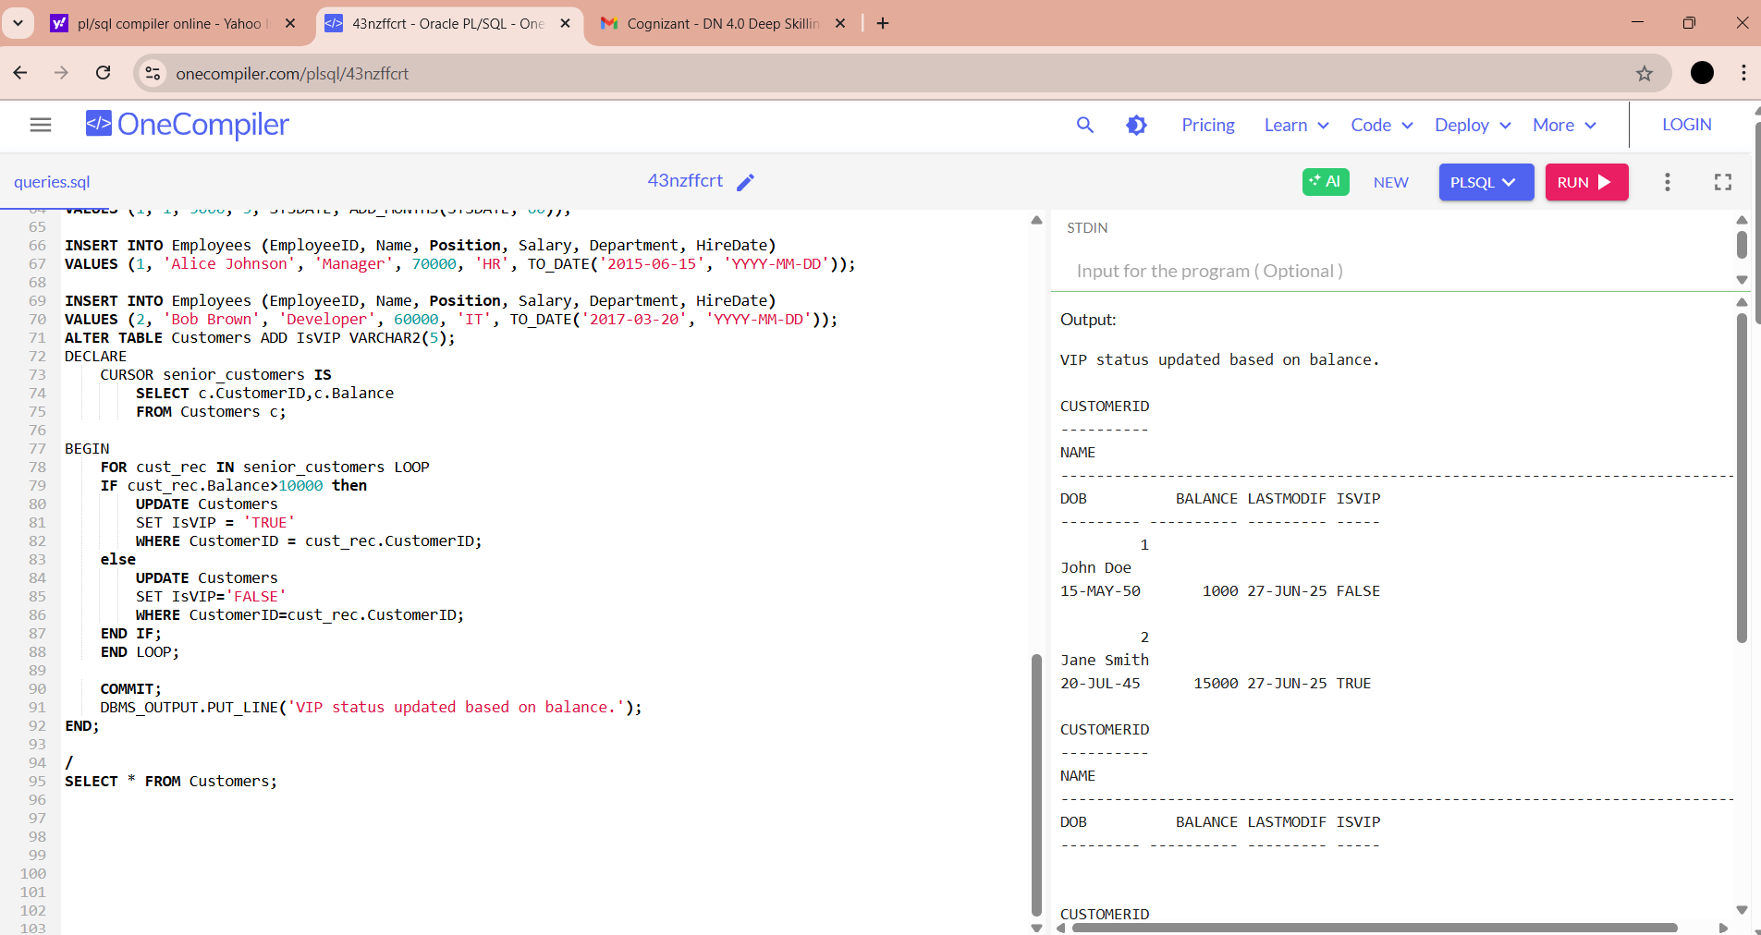

**Scenario 3: The bank wants to send reminders to customers whose loans are due within the next 30 days.**

* + **Question: Write a PL/SQL block that fetches all loans due in the next 30 days and prints a reminder message for each customer.**

INSERT INTO Loans (LoanID, CustomerID, LoanAmount, InterestRate, StartDate, EndDate)

VALUES (1, 1, 5000, 5, SYSDATE, ADD_MONTHS(SYSDATE, 1));

SELECT* FROM Loans;

BEGIN

FOR loan_rec IN ( SELECT l.LoanID,l.EndDate,c.Name

FROM Loans l

JOIN Customers c ON l.CustomerID=c.CustomerID

WHERE l.EndDate between SYSDATE AND SYSDATE+30

) LOOP

DBMS_OUTPUT.PUT_LINE('Remainder: Dear' || loan_rec.Name|| ',your loan(LoanId: '||loan_rec.LoanId||') is due on '|| TO_CHAR(loan_rec.EndDate, 'DD-MON-YYYY')

|| '.');

END LOOP;

END;

/

**OUTPUT:**

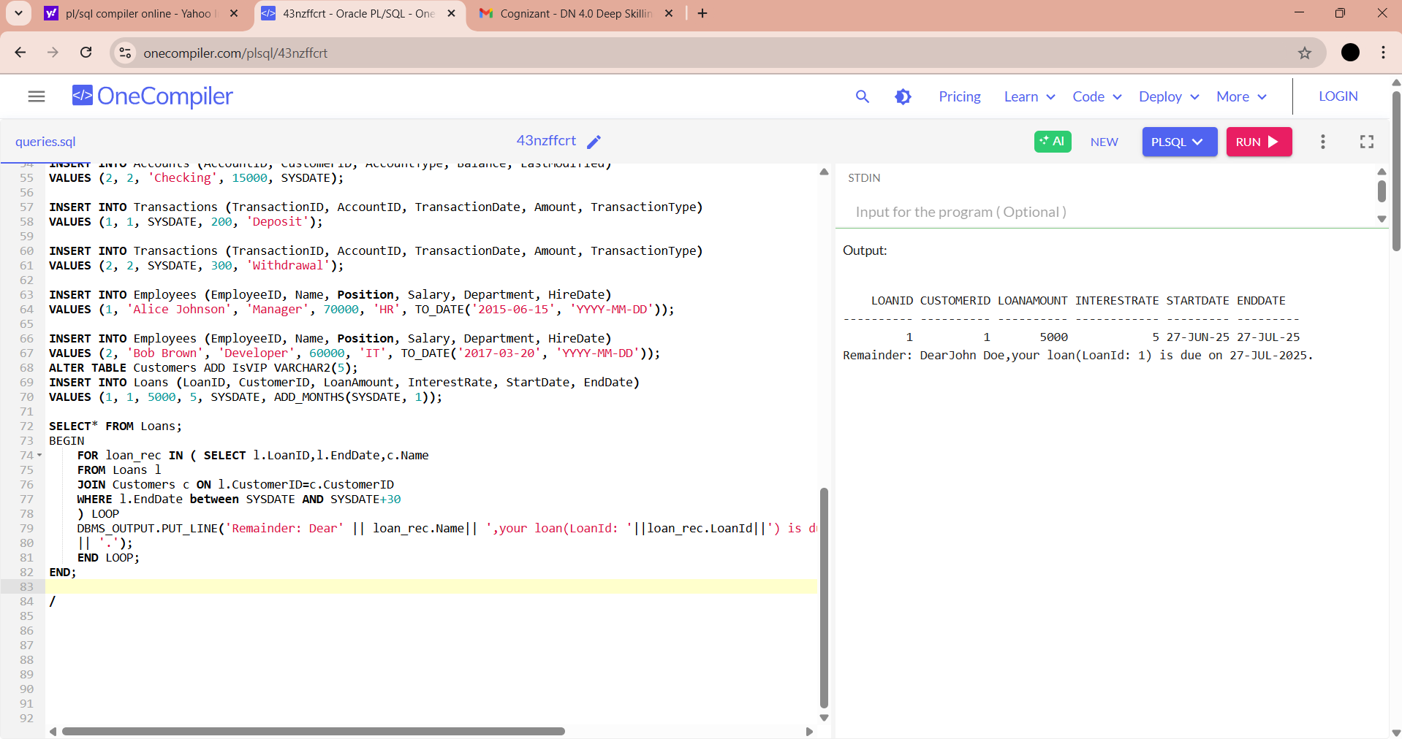

**Exercise 3: Stored Procedures**

**Scenario 1: The bank needs to process monthly interest for all savings accounts.**

* + **Question: Write a stored procedure ProcessMonthlyInterest that calculates and updates the balance of all savings accounts by applying an interest rate of 1% to the current balance.**

SELECT * FROM Accounts;

CREATE OR REPLACE PROCEDURE ProcessMonthlyInterest IS

BEGIN

UPDATE Accounts

SET Balance = Balance + (Balance * 0.01)

WHERE AccountType = 'Savings';

COMMIT;

DBMS_OUTPUT.PUT_LINE('Monthly interest for all savings accounts.');

END;

/

EXEC ProcessMonthlyInterest;

SELECT * FROM Accounts;

**OUTPUT:**

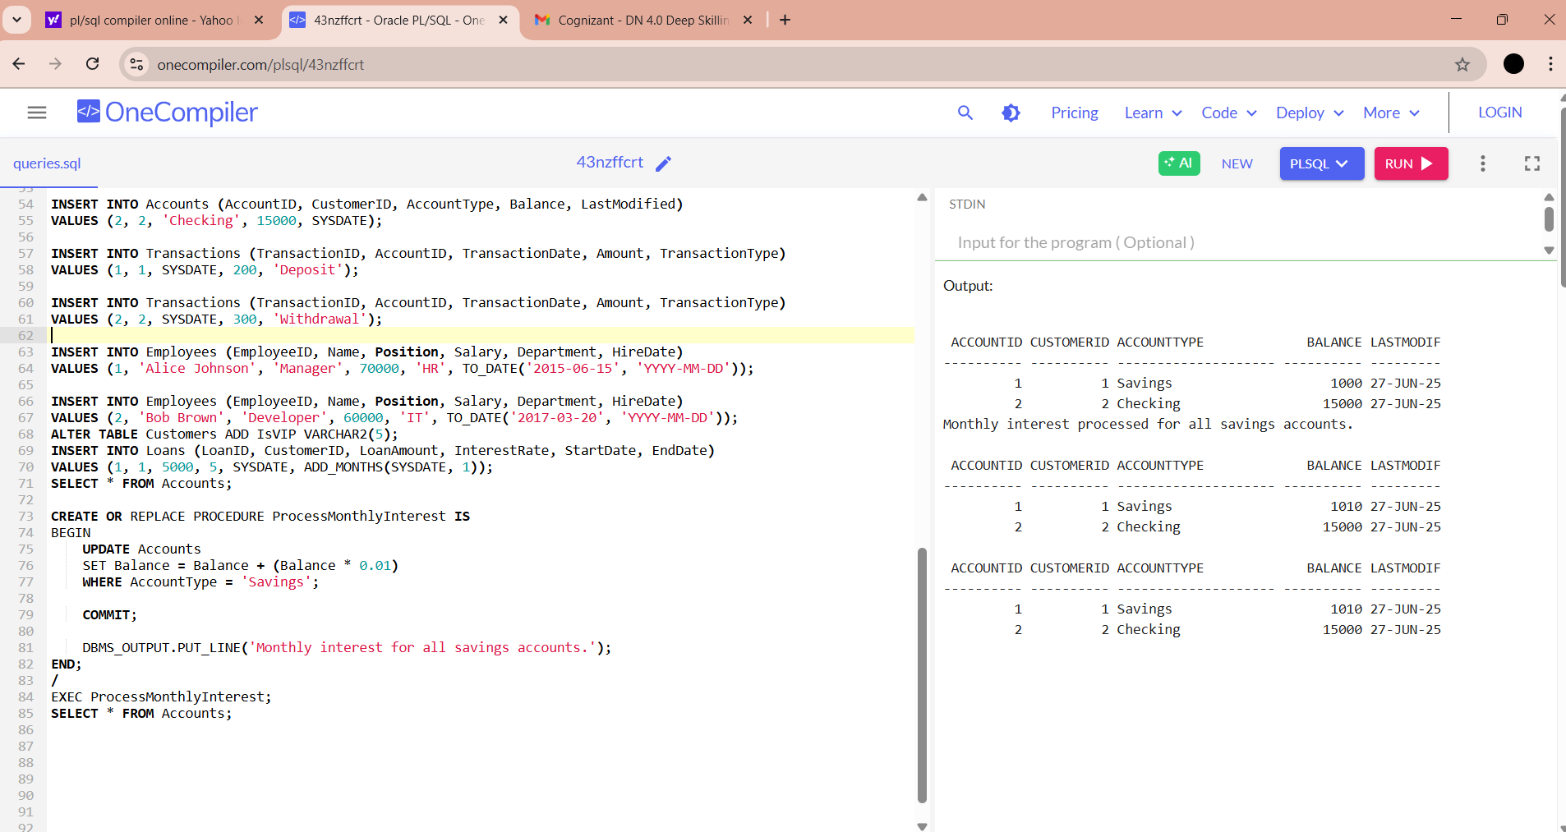

**Scenario 2: The bank wants to implement a bonus scheme for employees based on their performance.**

* + **Question: Write a stored procedure UpdateEmployeeBonus that updates the salary of employees in a given department by adding a bonus percentage passed as a parameter.**

CREATE OR REPLACE PROCEDURE UpdateEmployeeBonus (

p_Department IN VARCHAR2,

p_BonusPercent IN NUMBER

)

IS

BEGIN

UPDATE Employees

SET Salary = Salary + (Salary * p_BonusPercent / 100)

WHERE Department = p_Department;

COMMIT;

DBMS_OUTPUT.PUT_LINE('Bonus of '||p_BonusPercent||'% applied to department: '||p_Department);

END;

/

EXEC UpdateEmployeeBonus('IT',40);

SELECT * FROM Employees;

**OUTPUT:**

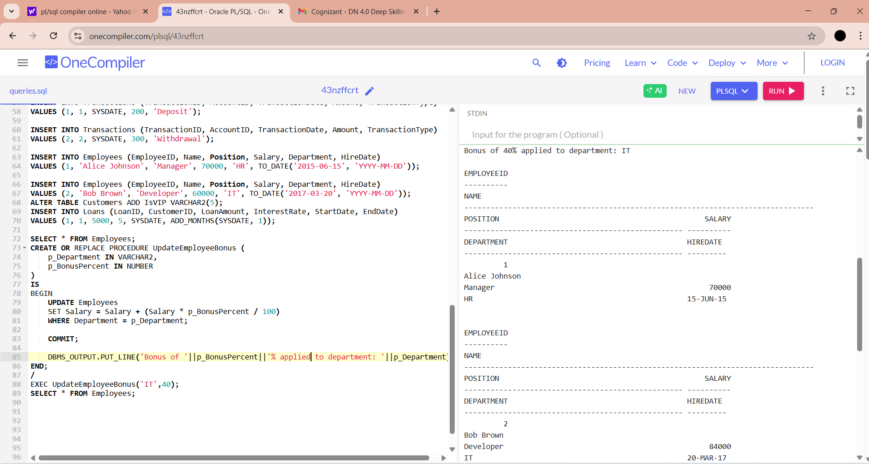

**Scenario 3:** Customers should be able to transfer funds between their accounts.

* + **Question:** Write a stored procedure **TransferFunds** that transfers a specified amount from one account to another, checking that the source account has sufficient balance before making the transfer.

SELECT * FROM Accounts;

CREATE OR REPLACE PROCEDURE TransferFunds (

p_SourceID IN NUMBER,

p_DestinationID IN NUMBER,

p_amount IN NUMBER

)

IS

v_SourceBalance NUMBER;

BEGIN

SELECT Balance INTO v_SourceBalance

FROM Accounts

WHERE AccountID=p_SourceID;

IF v_SourceBalance<p_amount THEN

RAISE_APPLICATION_ERROR(-20001,'INSUFFICIENT BALANCE IN SOURCE ACCOUNT.');

END IF;

UPDATE Accounts

SET Balance=Balance-P_amount

WHERE AccountID=p_SourceID;

UPDATE Accounts

SET Balance=Balance+P_amount

WHERE AccountID=p_DestinationID;

COMMIT;

DBMS_OUTPUT.PUT_LINE('TRANSFER OF '||p_amount||' FROM ACCOUNT'||p_SourceID||' TO ACCOUNT'||p_DestinationID||'COMPLETED SUCCESSFULLY.');

END;

/

EXEC TransferFunds(2,1,2000);

SELECT * FROM Accounts WHERE AccountID IN(1,2);

**OUTPUT:**

